## HW-2 SQL Queries - Instructions

**Database**: AdventureWorksLT2016.mdf

Show the SQL statement and the data results for each question below. Submit a Word document (no PDFs or other file types) with each SQL query (copied and pasted as text) followed by the image of the returned data only. The Windows snipping tool will allow you to capture the output from each query.

Example of how your work should be shown:

Q1. Select * From BuildVersion



1. Show the company name with which James D. Kramer works.

SELECT CompanyName

FROM SalesLT.Customer

WHERE FirstName = 'James' AND MiddleName = 'D.' AND LastName = 'Kramer'

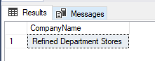

1. Show the customer ID, first name, last name and the email address of the customer whose company name is Bike World.

SELECT CustomerID, FirstName, LastName, EmailAddress

FROM SalesLT.Customer

WHERE CompanyName = 'Bike World'

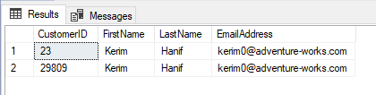

1. Show the company names for all customers with an address in the city of Dallas. Eliminate duplicates.

SELECT DISTINCT c.CompanyName

FROM SalesLT.Customer AS c

JOIN SalesLT.CustomerAddress

ON c.CustomerID=CustomerAddress.CustomerID

JOIN SalesLT.Address

ON CustomerAddress.AddressID=Address.AddressID

WHERE City = 'Dallas'

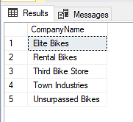

1. Show all the addresses listed for the company named Modular Cycle Systems.

SELECT a.AddressLine1, a.AddressLine2, a.City, a.StateProvince, a.CountryRegion, a.PostalCode

FROM SalesLT.Address AS a

JOIN SalesLT.CustomerAddress

ON a.AddressID=CustomerAddress.AddressID

JOIN SalesLT.Customer

ON CustomerAddress.CustomerID=Customer.CustomerID

WHERE CompanyName = 'Modular Cycle Systems'

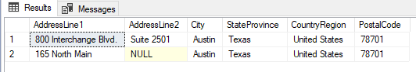

1. Show the order quantity, the product Name and the list price of the order made by the customer whose ID is 29877.

SELECT Detail.OrderQty, Prod.Name, Prod.ListPrice

FROM SalesLT.SalesOrderDetail AS Detail

JOIN SalesLT.SalesOrderHeader AS Header

ON Detail.SalesOrderID=Header.SalesOrderID

JOIN SalesLT.Product AS Prod

ON Detail.ProductID=Prod.ProductID

WHERE CustomerID = '29877'

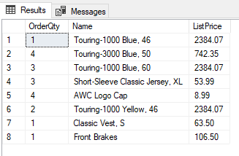

1. Show the company name and total amount due of those customers with orders over $100,000, along with the order subtotal, the tax and the freight.

SELECT Customer.CompanyName, Header.TotalDue, Header.SubTotal, Header.TaxAmt, Header.Freight

FROM SalesLT.SalesOrderHeader AS Header

JOIN SalesLT.Customer AS Customer

ON Customer.CustomerID=Header.CustomerID

WHERE Header.TotalDue>100000

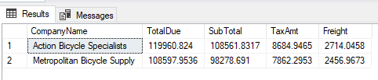

1. List all product names that belong to the product model called ‘Racing Socks’.

SELECT Prod.Name

From SalesLT.Product AS Prod

JOIN SalesLT.ProductModel AS Model

ON Prod.ProductModelID=Model.ProductModelID

WHERE Model.Name = 'Racing Socks'

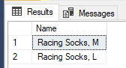

1. How many different items that have a list price of more than $1,000 have been sold? *(Note: this is the count of different products, not the total quantity of products that have been ordered, that meet the price criteria).*

SELECT COUNT(Items.ProductID) AS Items_Over_1000

FROM (SELECT DISTINCT Prod.ProductID

FROM SalesLT.Product AS Prod

JOIN SalesLT.SalesOrderDetail AS Details

ON Prod.ProductID=Details.ProductID

WHERE Prod.ListPrice > 1000) AS Items

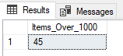

1. Find the quantity of large racing socks ('Racing Socks, L') ordered by the company named Riding Cycles.

SELECT Detail.OrderQty

FROM SalesLT.SalesOrderDetail AS Detail

JOIN SalesLT.SalesOrderHeader AS Header

ON Detail.SalesOrderID=Header.SalesOrderID

JOIN SalesLT.Product AS Prod

ON Detail.ProductID=Prod.ProductID

JOIN SalesLT.Customer AS Customer

ON Header.CustomerID=Customer.CustomerID

WHERE Customer.CompanyName='Riding Cycles' AND Prod.Name='Racing Socks, L'

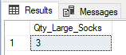

1. List the product name and the company name for all customers who ordered any products with a product model of 'Racing Socks'.

SELECT Prod.Name, Customer.CompanyName

FROM SalesLT.Product AS Prod

JOIN SalesLT.ProductModel AS Model

ON Prod.ProductModelID=Model.ProductModelID

JOIN SalesLT.SalesOrderDetail AS Detail

ON Prod.ProductID=Detail.ProductID

JOIN SalesLT.SalesOrderHeader AS Header

ON Detail.SalesOrderID=Header.SalesOrderID

JOIN SalesLT.Customer AS Customer

ON Header.CustomerID=Customer.CustomerID

WHERE Model.Name='Racing Socks'

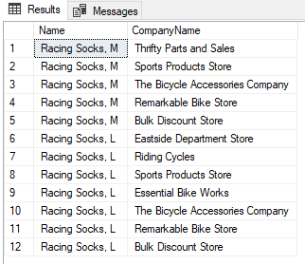

1. Use the SubTotal value in SaleOrderHeader to list orders from the largest to the smallest. For each order show the order ID, company name, the subtotal, and the total weight of the order.

SELECT Detail.SalesOrderID, Customer.CompanyName, Header.SubTotal, SUM(Prod.Weight * Detail.OrderQty) AS Total

FROM SalesLT.SalesOrderHeader AS Header

JOIN SalesLT.Customer AS Customer

ON Header.CustomerID=Customer.CustomerID

JOIN SalesLT.SalesOrderDetail AS Detail

ON Header.SalesOrderID=Detail.SalesOrderID

JOIN SalesLT.Product AS Prod

ON Detail.ProductID=Prod.ProductID

GROUP BY Detail.SalesOrderID, Customer.CompanyName, Header.SubTotal

ORDER BY Header.SubTotal DESC

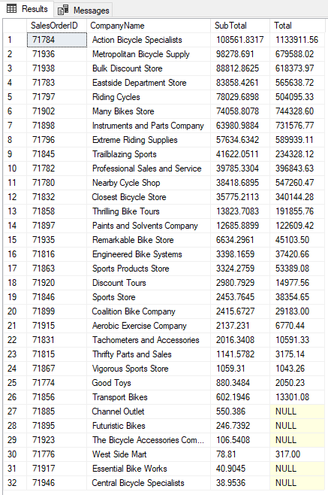

1. A "Single Item Order" is a customer order in which only one item is ordered. Show the SalesOrderID for every Single Item Order.
2. SELECT SalesOrderID
3. FROM SalesLT.SalesOrderDetail
4. GROUP BY SalesOrderID
5. HAVING COUNT(OrderQty) = 1

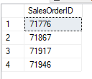

1. A "Single Item Order" is a customer order in which only one item is ordered. Show the SalesOrderID, Product ID, and the list price for every Single Item Order.

SELECT Detail.SalesOrderID, Detail.ProductID, Prod.ListPrice

FROM SalesLT.Product AS Prod

JOIN SalesLT.SalesOrderDetail AS Detail

ON Prod.ProductID=Detail.ProductID

WHERE Detail.SalesOrderID IN (SELECT SalesOrderID

FROM SalesLT.SalesOrderDetail

GROUP BY SalesOrderID

HAVING COUNT(OrderQty) = 1)

